
Regulations:
A15
SET-2
Sreenidhi Institute of Science and Technology
(An Autonomous Institution)
Code No: 5H111 Date:29-Dec-16 (FN)
B. TECH. I-Year I-Semester Examinations, Dec-2016/Jan-2017 (Regular)
ENGINEERING MATHEMATICS – I (Common to ME and IT)

Time: 3 Hours Max. Marks:75
Note: a) No additional answer sheets will be provided.
b) All sub-parts of a question must be answered at one place only, otherwise it will not be valued.
c) Assume any missing data.

Part - A
Max.Marks:25

Answer all QUESTIONS

- Find the Orthogonal Trajectory of the family of curve y = ax² where 'a' is the parameter. 3M
- Solve ( D⁴- 1)y=0. 3M
- Evaluate 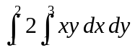 3M
- State Geometrical interpretation of Lagaranges Mean Value Theorem. 3M
- Define limit of the function f(x,y) at ( a, b). 3M
- Form a differential Equation for L- R Circuit whose Resistance R , Inductance L and applied e.m.f is E₀ 2M
- Find 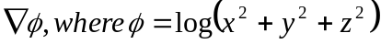. 2M
- State Surface Integral with geometrical interpretation. 2M
- A particle moves along the curve x=e^{-t} , y= 2 Cos3t.
Z= 2 Sin3t, where ‘ t ‘ is time variable , find its velocity and its magnitude at t=0. 2M
- State Newton's Law of cooling. 2M

Part – B
Max.Marks:50
ANSWER ANY FIVE QUESTIONS. EACH QUESTION CARRIES 10 MARKS.
1a) Solve 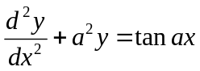 using method of variation of parameters. 5M
b) Solve (D² +5D +6)y =e^{-2x}Sin2x 5M

2a) Evaluate 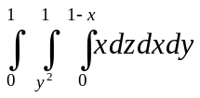 5M
b) Find the Area of Curve r²=a²Cos2θ by double Integration. 5M

3 a) Evaluate Curl (Grade f) where f= x²+y²-z² 5M
b) Find Curl (Curl A) , where A=( x²y)i +( y²z)j+(z²y) k 5M

4 a) Verify Greens theorem for 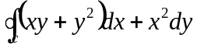 where C is bounded by 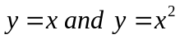. 5M
b) Evaluate 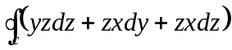 where C is the curve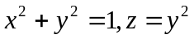. 5M

5a) prove that 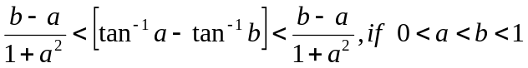 5M
b) Expand f(x) = e^{x}Cosx up to third degree term. 5M

6a) Solve 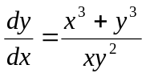 5M
b) Solve 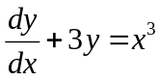 5M
7 a) If u= Sin⁻¹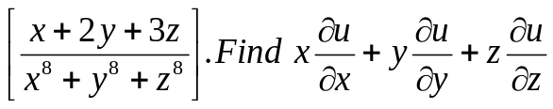 5M
b) Find the Orthogonal Trajectory of family of Cardioid r=a(1-Cosθ) where a>0. 5M

8 a) Show that 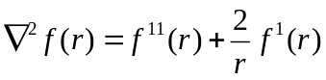 5M
b) Evaluate 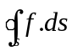 where 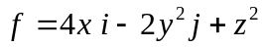and S is the surface bounding region 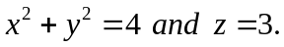
5M

-- 00 -- 00 --

